# MAD Project Proposal

**Submitted to:**

* Mam Hina Khalid

**Submitted by:**

* 2016-CS-178
* 2016-CS-122

**Department of Computer Science and Engineering**

**UET Lahore**

**Date:** 24-Nov-2019



Table of Contents

MAD Project Proposal 1

Project Description 3

Key Features 3

Entity Relationship Diagram 4

Wireframes 5

Main Screen 5

Control Screen 6

Sensor Monitor Screen 7

Side Menu 8

GPS Sensor 9

Temperature Screen 10

Humidity Screen 11

Orientation Screen 12

# Project Description

This project is an android application that is used to control Arduino (and similar boards) via Bluetooth and Wi-fi, and so to create awesome and fully customized projects, with the new features available within the app. The settings section allows you to adapt the application to your needs, through a very simple and intuitive interface.

# Key Features

* Remote control over Wi-fi or Bluetooth
* Live stream over Wi-fi
* Gyroscope/Accelerometer remote control support
* Sensor monitoring
* Graph plot using sensor data history
* Database support

# Entity Relationship Diagram

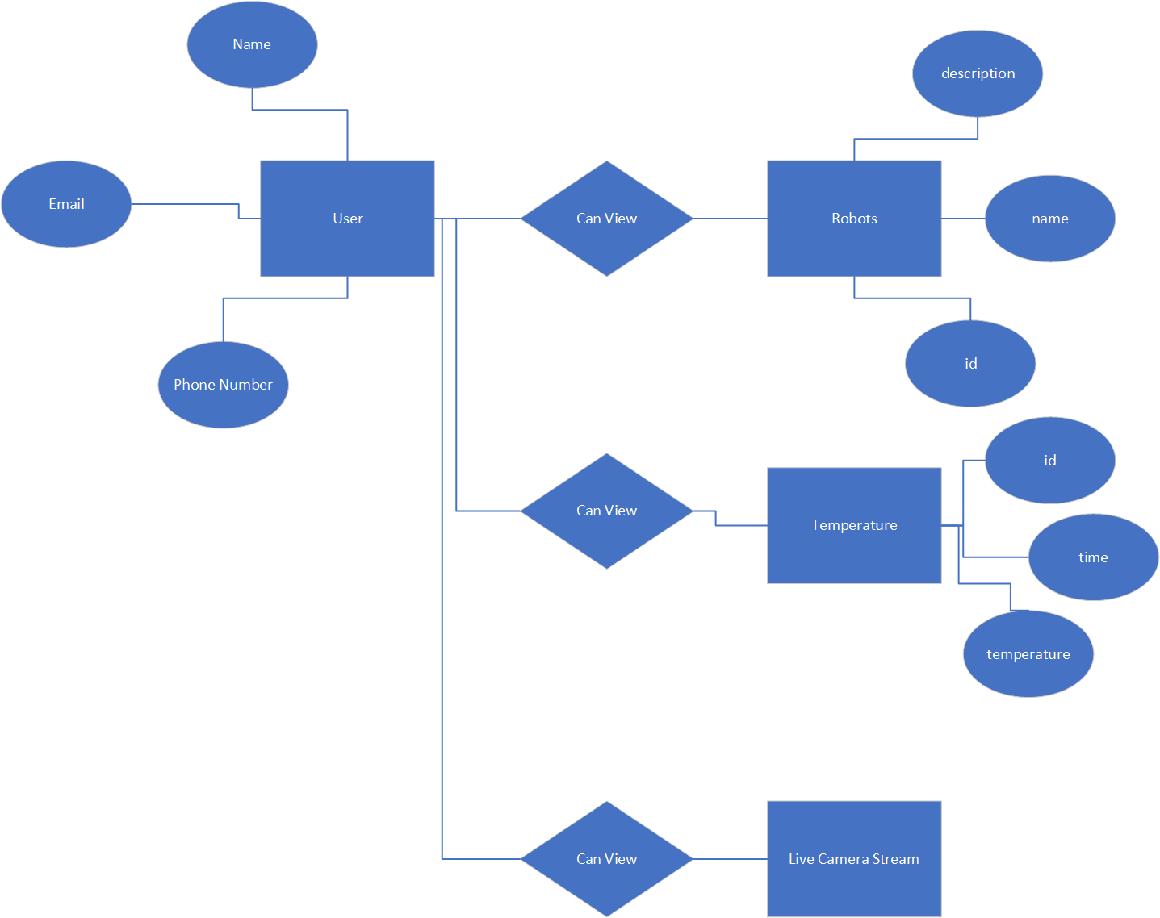

# Wireframes

## Main Screen

## Control Screen

## Sensor Monitor Screen

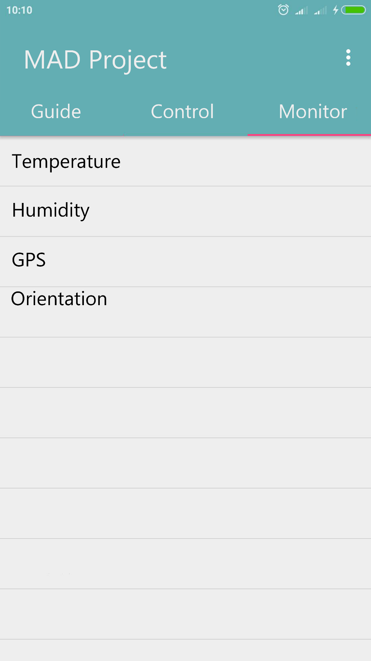

## Side Menu

## GPS Sensor

## Temperature Screen

## Humidity Screen

## Orientation Screen

